Selectika SFRA Integration Guide



**Table of Contents**

1. Summary 3

2. Component Overview 4

2.1 Functional Overview 4

2.2 Limitations, Constraints 4

2.3 Privacy, Payment 4

3. Implementation Guide 5

3.1 Cartridges Overview 5

3.2 How to implement 5

Install cartridges 5

Import metadata 5

Configure job 5

Configure service 6

Configure Merchant ID setting 6

4. Known Issues 7

5. Release History 8

# Summary

This document provides technical instructions for using the Selectika Salesforce Commerce Cloud Cartridge to integrate Selectika recommendations component into an SFCC storefront.

**Glossary**

|  |  |
| --- | --- |
| **Term** | **Description** |
| SFCC | Salesforce Commerce Cloud |
| Business Manager (BM) | The primary tool used to configure the SFCC platform and customer storefront |
| SFRA | The SFCC default ecommerce storefront |

# Component Overview

## Functional Overview

The Selectika cartridge enhanced recommendations to be used on the merchant Storefront.

## Limitations, Constraints

Use of the Selectika SFCC Cartridge requires a merchant account and FTP credentials. Please go to the Selectika website to sign up for the services (<https://selectika.com>)

## Privacy, Payment

The Selectika cartridge does not collect and process any user profile information or billing information.

# Implementation Guide

## Cartridges Overview

The implementation consists of two cartridges: **int_selectika_core** and **int_selectika_sfra**.

The **int_selectika_core** cartridge contains core functionality, product feed generation job logic and necessary utility functions.

The **int_selectika_sfra** implements the recommendation web component integrations into SFRA storefront.

## How to implement

The Selectika cartridge enhanced recommendations to be used on the merchant Storefront.

### Install cartridges

Add both **int_selectika_core** and **int_selectika_sfra** cartridges to your code version. In BM go to **Administration > Sites > Manage Sites**. Select the relevant site, then select the **Settings** tab. In the cartridge path, add the **int_selectika_core** and **int_selectika_sfra** cartridges.

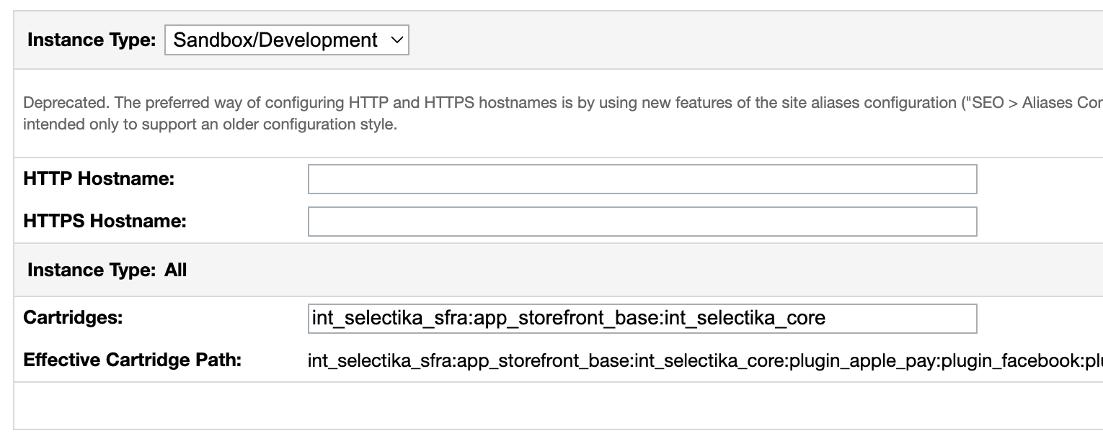

### Import metadata

Import metadata from the metadata folder. The metadata contains site preferences extensions, services and jobs, needed for the functionality to work.

### Configure job

The **Selectika Export CSV** job consists of two steps: generate CSV and uploads it to a Selectika FTP server. The CSV generation job step can be configured to generate your catalog feed correctly. The following settings can be configured:

1. **Target folder**. The folder path relative to the IMPEX folder to save the generated CSV feed file to.
2. **ProductTypeStrategy.** There are two options to determine a product type.
   1. **Category.** Specify the category depth for a category to represent product type. For example root > mens (0) > jeans (1) would represent product type jeans and have depth 1. Controlled by the **ProductTypeCategoryDepth** setting.
   2. **Custom Field.** A product custom field name representing the product type. Controlled by the **ProductTypeField** setting.
3. **GenderStrategy.** There are two options to determine a product’s gender.
   1. **Category.** Specify the category depth for a category to represent a gender. For example root > mens (0) would represent men and have depth 0. Controlled by the **GenderCategoryDepth** setting.
   2. **Custom Field.** A product custom field name representing a gender. Controlled by the **GenderField** setting.
4. **ImageType.** Which image size to use.
5. **ParentProductStrategy.** There are two options to determine a master product.
   1. **ID Section.** Use part of product’s ID as master ID. For example, if we know, that int a variant ID 12345WHM, 12345 stands for master product, WH stands for color, M stands for size, then ID section 1-5 will be used as master ID. Controlled by the **ParentProductIdSectionStart** and **ParentProductIdSectionEnd** settings.
   2. **Master Product.** Get product’s master product ID.
6. **ColorStrategy.** There are two options to determine a color.
   1. **ID Section.** Use part of product’s ID as master ID. For example, if we know, that int a variant ID 12345WHM, 12345 stands for master product, WH stands for color, M stands for size, then ID section 5-7 will be used as color. Controlled by the **ColorIdSectionStart** and **ColorIdSectionEnd** settings.
   2. **Variation Attribute Value.** Use product’s variation attribute. Controlled by the **ColorVariationAttributeName** setting.
7. **SizeStrategy.** There are two options to determine a size.
   1. **ID Section.** Use part of product’s ID as master ID. For example, if we know, that int a variant ID 12345WHM, 12345 stands for master product, WH stands for color, M stands for size, then ID section 7-.. will be used as size. Controlled by the **SizeIdSectionStart** and **SizeIdSectionEnd** settings.
   2. **Variation Attribute Value.** Use product’s variation attribute. Controlled by the **SizeVariationAttributeName** setting.
8. **BrandField.** Custom field name representing product’s brand.

### Configure service

By default, the feed job uses the selectika.ftp service. Please contact Selectika for credentials.

### Configure Merchant ID setting

The merchant ID can be configured under **Merchant Tools > Site Preferences > Custom Preferences > Selectika > Merchant ID.** It’s used in the CSV generation job and in storefront Web component. Please contact Selectika to get one assigned.

# Known Issues

*Intentionally left blank.*